**Assignment 3**

**กลุ่ม ขอบตาดำ ไปก่อนละกัน**

**สมาชิก 1. นางสาวธัญชนก จรุงพัฒนานนท์ 64010259**

**2. นายธนทัต จงกิตติสกุล 64010312**

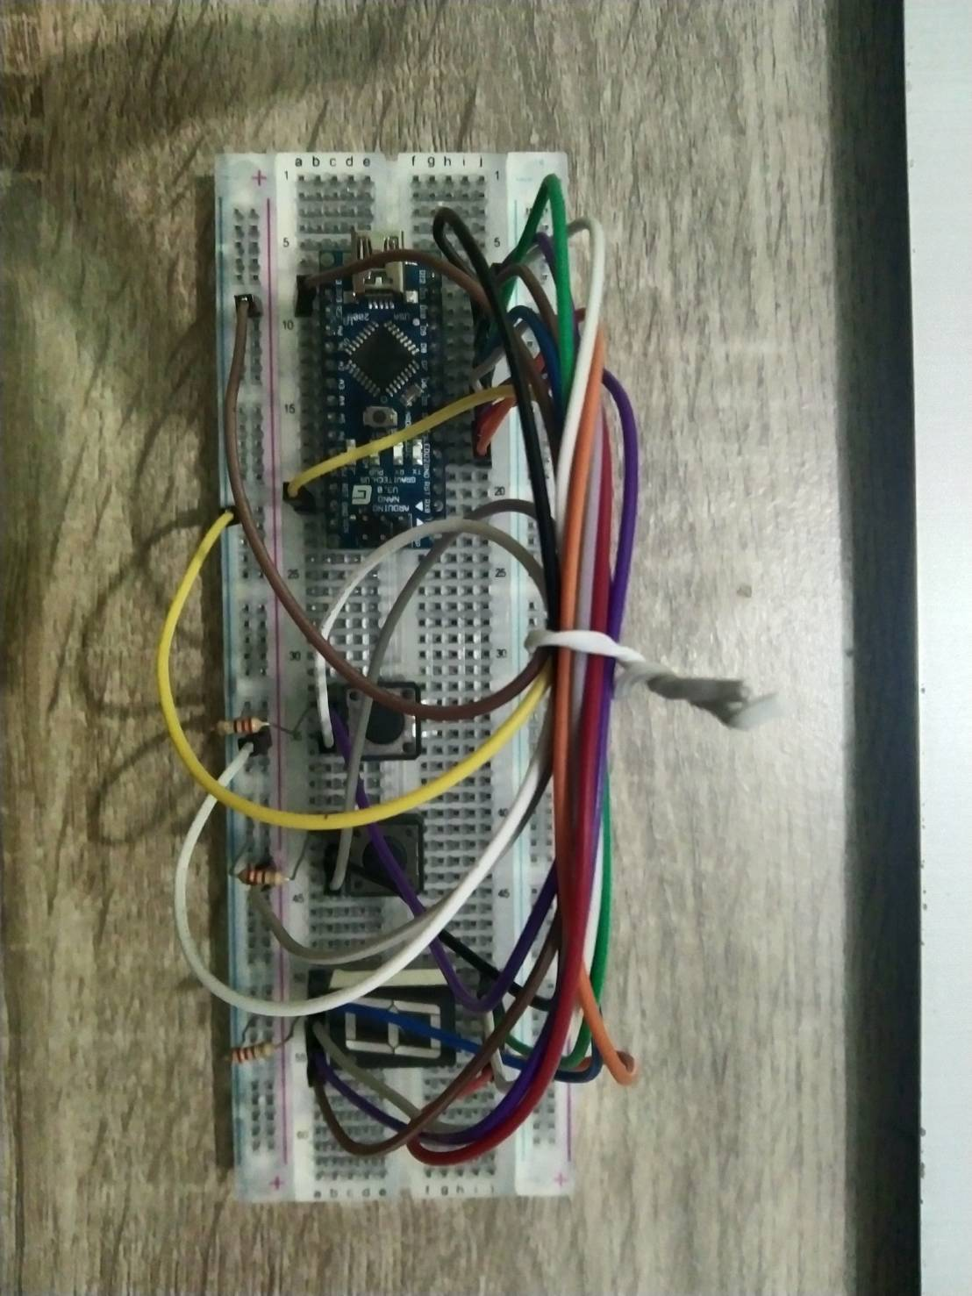

**รูปถ่ายชิ้นงาน**

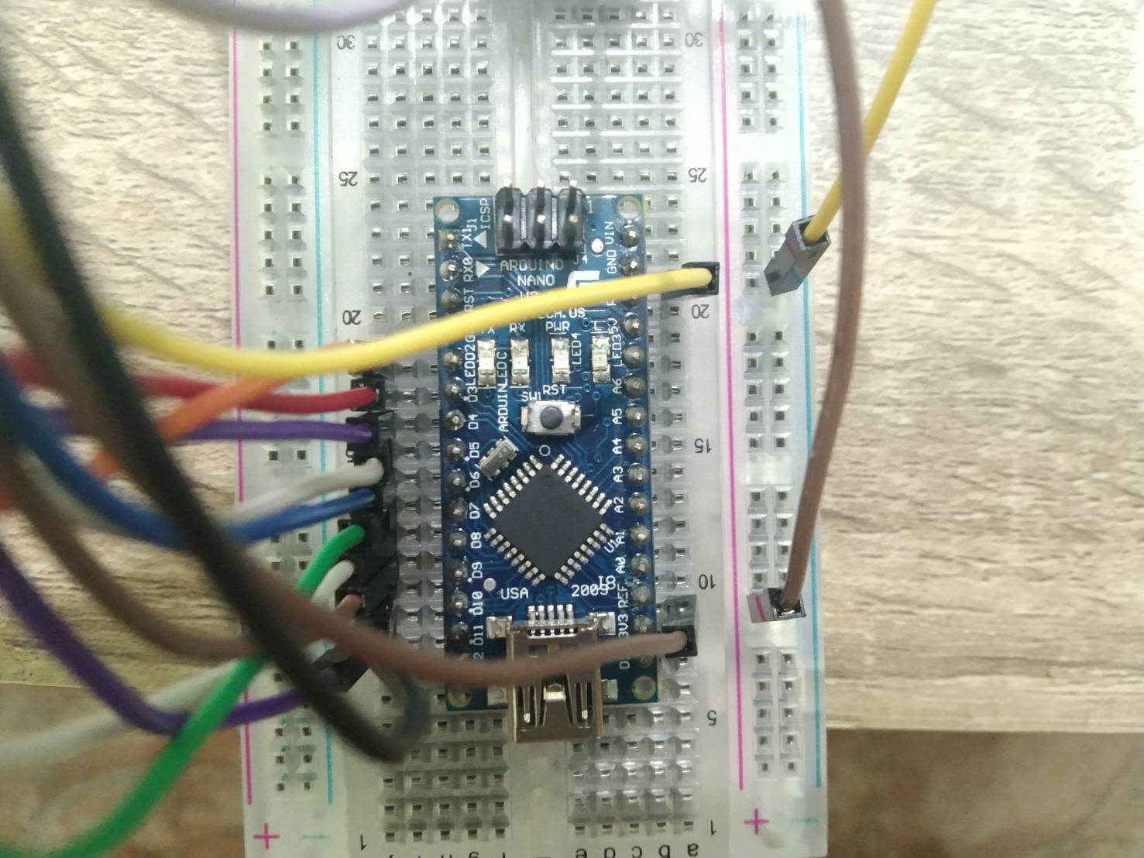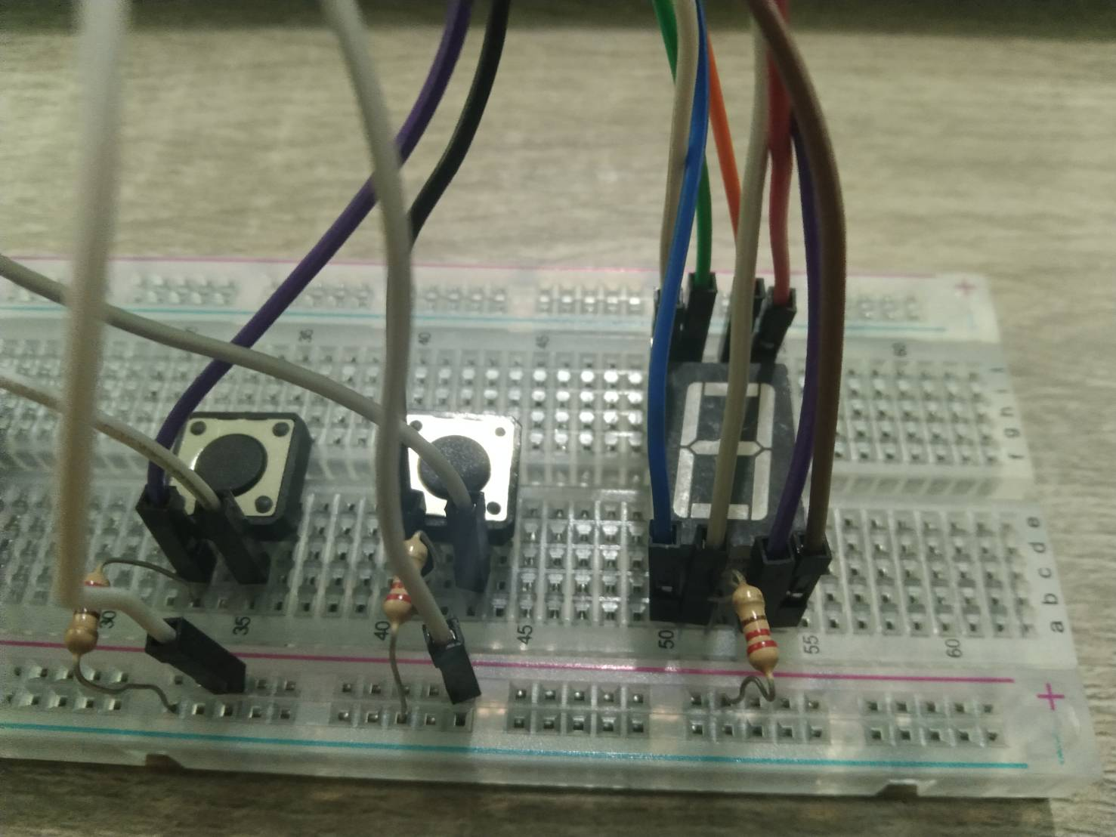

**Source Code**

**int bitPattern [10] = {B11000000, B11111001, B10100100, B10110000, B10011001, B10010010, B10000010, B11011000, B10000000, B10010000};**

**const byte numPins = 8;**

**const int segmentPins[8] = {2, 3, 4, 5, 6, 7, 8, 9};**

**int a = 1;**

**int b = 0;**

**int b2 = 0;**

**int randomNo;**

**void setup()**

**{**

**for (int i = 0; i < numPins; i++)**

**pinMode(segmentPins[i], OUTPUT);**

**pinMode(10, INPUT);**

**pinMode(11, INPUT);**

**randomSeed(analogRead(A0));**

**randomNo = random(1, 10); }**

**void loop()**

**{**

**int ck = digitalRead(10);**

**boolean isBitSet;**

**if (ck == 1 && b == 0**

**{**

**b = 1;**

**a++;**

**}**

**else if (ck == 0) b = 0;**

**if (a == 10) a = 1;**

**for (int segment = 0; segment < 8; segment++)**

**{**

**isBitSet = bitRead(bitPattern[a], segment);**

**digitalWrite(segmentPins[segment], isBitSet);**

**}**

**watt();**

**}**

**void watt()**

**{**

**boolean isBit;**

**boolean SetisBit;**

**int ck2 = digitalRead(11);**

**if (ck2 == 1 && b2 == 0)**

**{**

**b2 = 1;**

**if (a == randomNo)**

**{**

**a = 0;**

**randomNo = random(1, 10);**

**}**

**else if (a > randomNo)**

**{**

**int g = B11000010;**

**for (int segment = 0; segment < 8; segment++)**

**{**

**isBit = bitRead(g, segment);**

**digitalWrite(segmentPins[segment], isBit);**

**}**

**delay(1000);**

**}**

**else if (a < randomNo)**

**{**

**int l = B11000111;**

**for (int segment = 0; segment < 8; segment++)**

**{**

**SetisBit = bitRead(l, segment);**

**digitalWrite(segmentPins[segment], SetisBit);**

**}**

**delay(1000);**

**}**

**}**

**else if (ck2 == 0) b2 = 0;**

**}**